**Module 2 Assignment: Variables and Constants with Arithmetic Calculations using Flowcharting**

**Exercise 1**

1. **Hierarchy Chart**

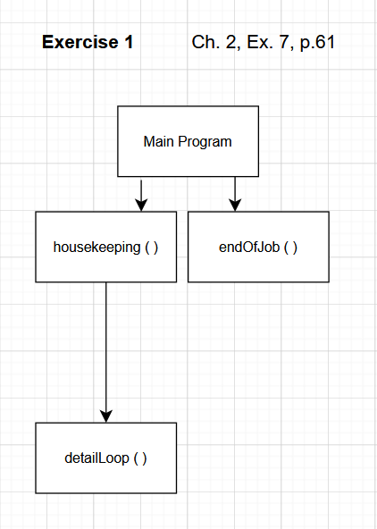

1. **FLOWCHART**

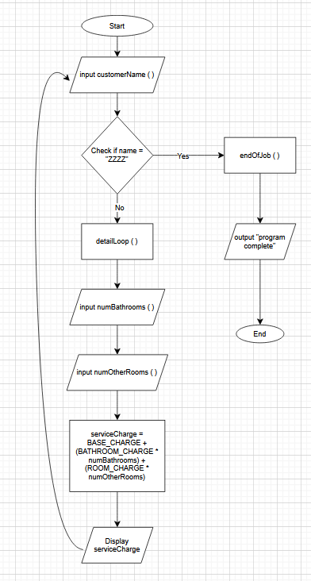

1. **PSEUDOCODE**

Main Module

Declare string customerName

Declare numBathrooms, NumOtherRooms

Declare serviceCharge

Constant BASE_CHARGE = 15

Constant BATHROOM_CHARGE = 15

Constant ROOM_CHARGE = 10

Call Housekeeping (customerName)

While customerName != “ZZZZ”

Call DetailLoop (customerName, numBathrooms, numOtherRooms, serviceCharge)

Call Housekeeping(customerName)

End While

Call EndOfJob()

End Main

Housekeeping (customerName)

Display “Enter customer’s last name (or ZZZZ to quit): “

input customerName

End Housekeeping

DetailLoop(customerName, numBathrooms, numOtherRooms, serviceCharge)

Display “Enter number of bathrooms for “ + customerName + “: “

Input numOtherRooms

serviceCharge = BASE_CHARGE + (BATHROOM_CHARGE * numBathrooms) + (ROOM_CHARGE * numOtherRooms)

Display “Service charge: $ “ + serviceCharge

End DetailLoop

EndOfJob()

Display “Program Complete.”

End EndOfJob

GITHUB: <https://github.com/kdswaim/computing-logic-assignment/tree/main>